MILESTONE 3

USER ADMIN MODULE

Tim A James

GCU | CST-236 DATABASE APPLICATIONS II | 3/16/21

# GITHUB REPO URLS

MILESTONE 3 REPO: https://github.com/tjames222/CST-236/tree/main/WEEK%202/MILESTONE%202

ECOMMERCE SITE REPO: <https://github.com/tjames222/CST-236/tree/main/EcommerceSite>

PLEASE SEE LOOM VIDEO AT BOTTOM OF REPORT FOR DETAILS. I NEED SOME HELP.

# WIREFRAMES

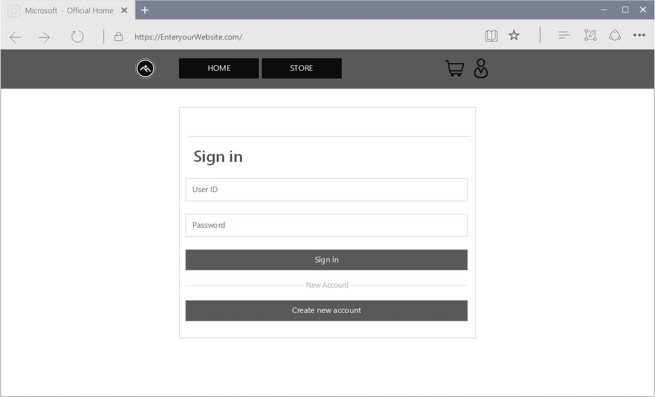Login Page.

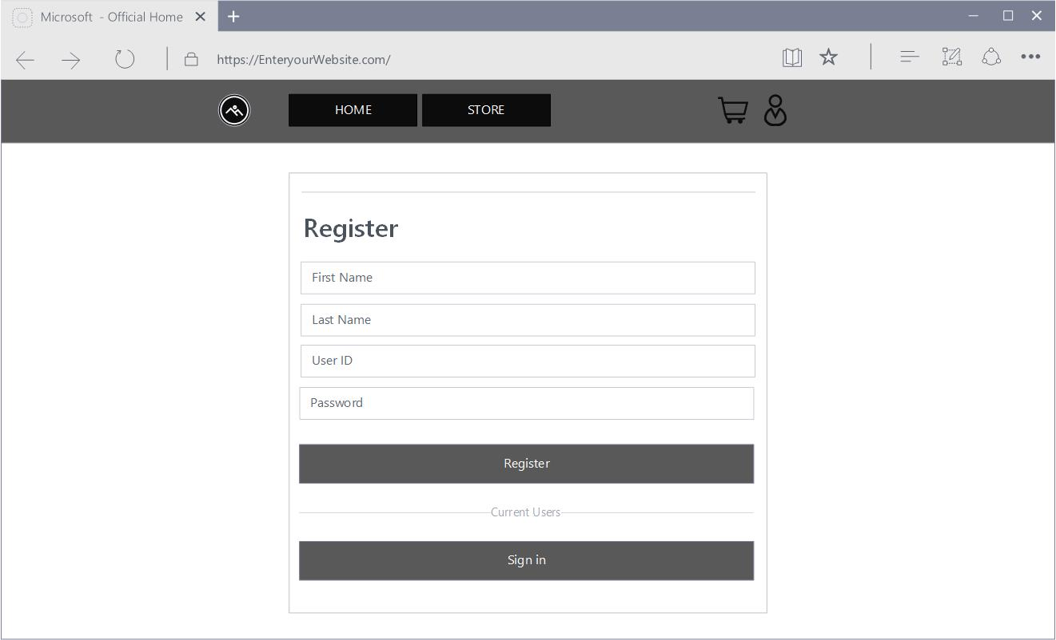Register page.

# ER DIAGRAM

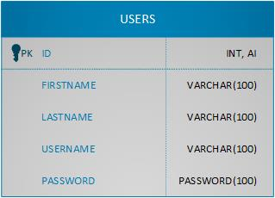Users ER diagram

# UML DIAGRAM

User Class UML Diagram.

# 

# DATA DICTIONARY

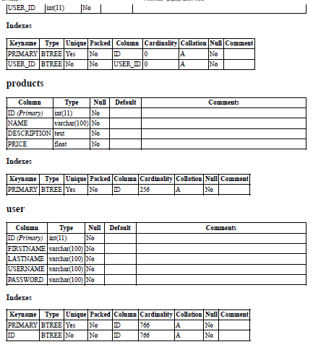

# ER DIAGRAMS PK FK Relations

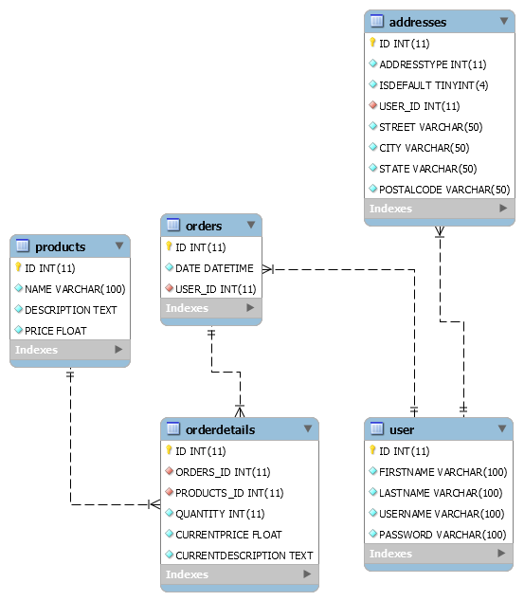

# SCREENCAST URL

https://www.loom.com/share/a32019d1b3654cb1bc6b97a0c06c9174